**Homework 2**

Chapter 3: Test Automation

**Name: Antonio Zea Jr**

**What to do?**

Complete the problems below and submit a zip file containing this word document and the code file requested below.

1. **Refer to Chapter 3, problem #6. (40 points)**

Consider PrimeNumbers.java class (PrimeNumbers.java is attached to this assignment). This class has three methods as follows:

* + - computePrimes() à takes one integer input and computes that many prime numbers • iterator() à returns an Iterator that will iterate through the primes
    - toString() à returns a string representation of primes.

computePrimes() has a fault that causes it **not** to include prime numbers whose last digit is 9. For example, it omits 19, 29, 59, 79, 89, 109,…

Answer the following questions a through f, if the test could be created describe what the test case would be or explain why it cannot be created:

* 1. A test that does not reach the fault

Choosing 0 as the input for computePrimes skips the fault completely.

* 1. A test that reaches the fault, but does not infect (ie. error)

Choosing 7 as the input for computePrimes reaches the fault but does not cause an error state.

* 1. A test that infects the state, but does not propagate (ie. failure)

Not possible, if an error state is achieved then it necessarily means that a prime that ended with a 9 was skipped. This constitutes a failure and will be necessarily propagated.

* 1. A test that propagates, but does not reveal

Not possible, if a test propagates then it will necessarily not produce a prime number that was supposed to be added to the ArrayList. This failure will always reveal the failure.

* 1. Write a Junit test that reveals the fault for the following input.

computePrimes(8);

Expected = [2, 3, 5, 7, 11, 13, 17, 19]

Result = [2, 3, 5, 7, 11, 13, 17, 23]

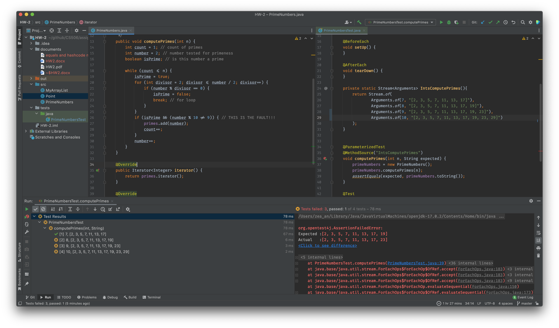

* 1. After repairing the fault, write a data-driven Junit test for the toString method with at least 3 different values. In particular, this data-driven test method should test toString method using @ParameterizedTest based on the results of computePrimes method for n = 7, 8 and 9.

**Note: For e and f, submit the code for a Junit test class, PrimeNumbersTest.java.**

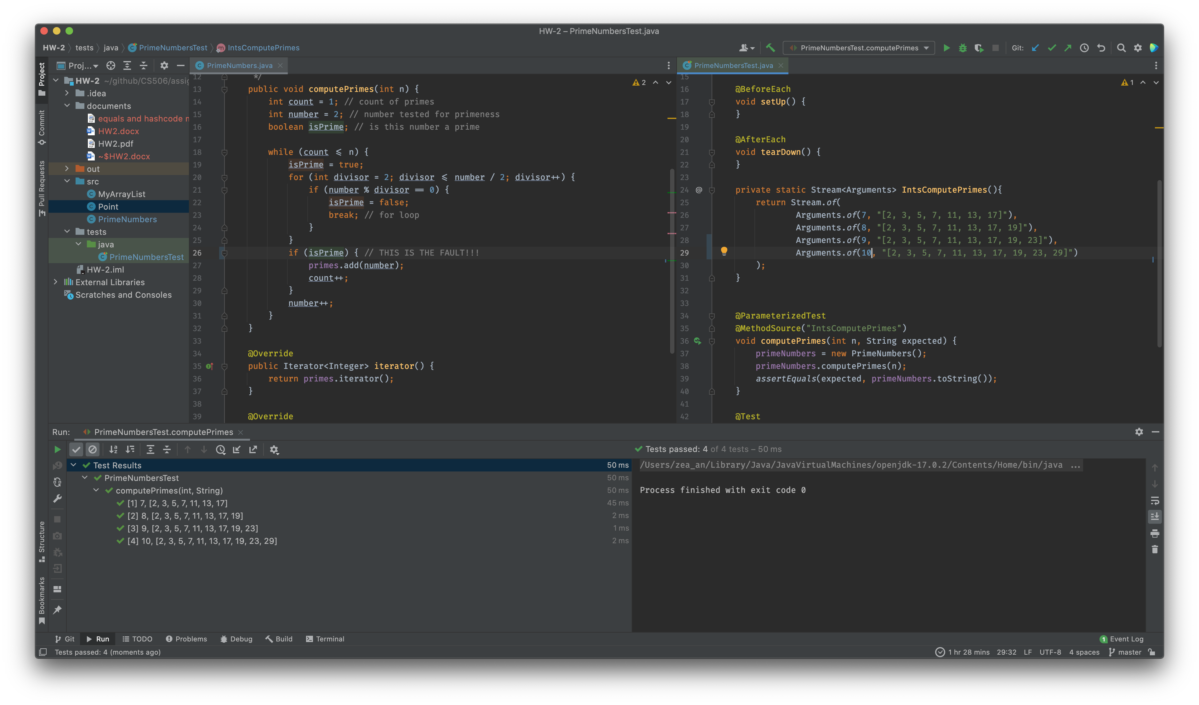

1. **Refer to Chapter 3, problem #9 (15 points)**

When overriding the equals() method, programmers are also required to override the hashCode() method; otherwise clients cannot store instances of these objects in common Collection structures such as HashSet. For example, the Point class from Chapter 1 is defective in this regard (Point.java is attached to this assignment).

* + 1. Demonstrate the problem with Point using a HashSet

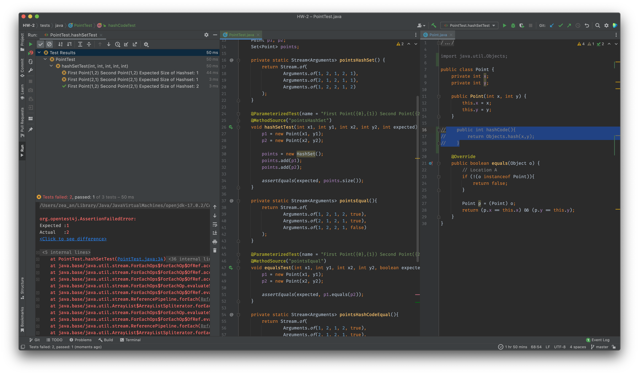

* + 1. Write a simple Junit test to show that Point objects do not enjoy this property (i.e., before fixing the problem)

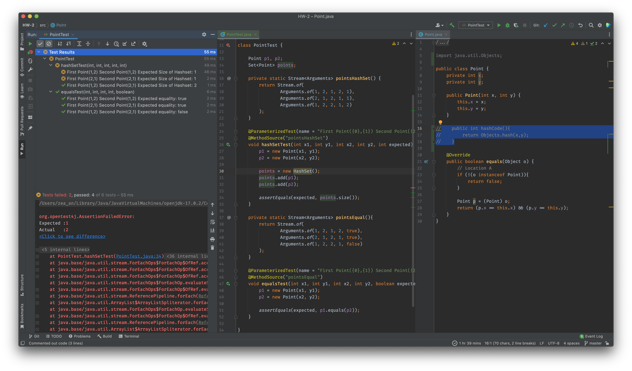

* + 1. Repair the Point class to fix the fault

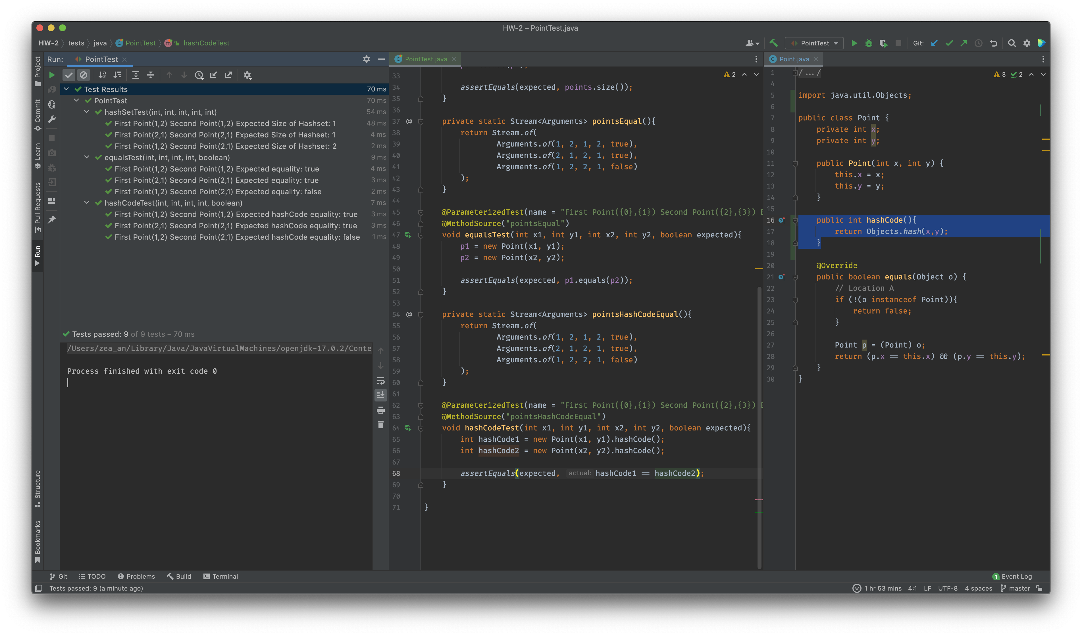

1. **You can take a look at MinTest.class under in-class example for reference (45 points)**

Develop JUnit tests for the MyArrayList class, which is attached to this assignment on Blackboard. Make sure that your tests check every method in this class with test cases that include exceptional and normal behaviors. Submit the code for a Junit test class (e.g., you can name the class containing your test methods as MyArrayListTest).

The following can be helpful for you to understand how you can utilize the methods in this class. In your test methods, you do not really need to print anything, though.

*// Array can be any type. I choose String below as an example*

MyArrayList<String> myArrayList = **new** MyArrayList<>();

*// Array can be declared with an initial capacity of the list*

*// MyArrayList<String> myArrayList = new MyArrayList<>(2);*

myArrayList.add(**"cat"**); myArrayList.add(**"dog"**); myArrayList.add(**"rabbit"**);

*// add() method can be used to add an element to a certain index such as shown below* myArrayList.add(3, **"bear"**);

*// get() method can be used to access an element at certain index*

System.***out***.println(**"Element at index 1: "** + myArrayList.get(1));

*// size() method can be used to get the number of elements in this list.*

System.***out***.println(**"List size: "**+ myArrayList.size());

*// remove() method removes the element at index provided*

System.***out***.println(**"Removing element at index 1: "** + myArrayList.remove(2));

*// Print the list for fun*

System.***out***.println(**"List: "** + myArrayList);

**Due Date**

This homework is due by **Friday, February 18, 2022, 11:59 pm.** A penalty of 10% per day will be deducted from your grade, starting at 12:00:01 am.

**What to submit?**

Submit a zip file that contains the following on Blackboard:

• A word document describing your answers to the questions above. • The code files requested above